FAST-NUCES
Fundamentals of Software Engineering Spring 2026
LitLog
Personal Reading Tracker & Habit Visualizer
Iteration 2 Deliverable Report
Zahra Saeed 24L-2512
Romaisa Sajjad 24L-2608
Khadija Faiz 24L-2554
Submission Date: April 11, 2026

1. Project Introduction
LitLog is a personal reading tracker and habit visualizer designed to help users manage their entire reading journey in one place. Readers often struggle to remember which books they have read, track their current progress, or recall their thoughts on finished books. LitLog solves this by providing a clean, organized desktop web application where users can add books, organize them across shelves, write personal notes, set reading goals, and receive book recommendations all stored securely in a local SQL Server database.
This document covers the Sprint 2 deliverable, which includes Module 3 (Ratings, Notes & Summaries) and Module 4 (Progress Tracker & Goals). The sprint ran from March 23rd to April 11, 2026.

2. User Stories
The following user stories were selected for Sprint 2, covering Modules 3 and 4.

US-05: Bookshelf Management
Story ID: US-05 Story Title: Bookshelf Management
User Story:  As a user, I want to organize my books into shelves and move them between shelves at any time so that I can clearly see which books I am reading, have finished, or plan to read.  Description:  This story covers the four-shelf system that is the core organisation mechanism of LitLog. Users can view all books grouped by their current status and reassign any book to a different shelf through a simple interaction on the book card.  Sub User Stories:  - As a user, I want to see my books separated into four shelves: Currently Reading, Want to Read, Finished, and Did Not Finish.  - As a user, I want to move a book to a different shelf with a single click or selection.  - As a user, I want the shelf count to update immediately when I move a book.  Acceptance Criteria:  - The bookshelf screen displays four named sections, each showing the books assigned to that status.  - Each book card has an option (dropdown) to change its shelf.  - Moving a book updates its status in the database immediately.  - The book disappears from the previous shelf and appears on the new one without a page reload.  - Each shelf displays the correct count of books it contains. | Priority:  High  Estimated Hours:  4

US-07: Ratings & Notes
Story ID: US-07 Story Title: Ratings & Notes
User Story:  As a user, I want to rate a book out of 5 stars and add personal notes to it so that I can keep track of my opinions and thoughts about books I have read.  Description:  This story involves building a ratings and notes interface accessible from each book's detail view. Users can assign a star rating from 1 to 5 and write free-text notes. Both the rating and notes are saved to the database and displayed whenever the user views that book.  Sub User Stories:  - As a user, I want to select a star rating (1 to 5) for any book in my library.  - As a user, I want to write free-text notes about a book.  - As a user, I want my rating and notes to be saved and visible the next time I open the book.  - As a user, I want to edit or delete my rating and notes at any time.  Acceptance Criteria:  - A rating control (1–5 stars) is available on the book detail screen.  - A notes text area is available on the book detail screen.  - Both rating and notes are saved to the database when the user confirms.  - The saved rating and notes are displayed whenever the book detail screen is opened.  - The user can update or clear the rating and notes at any time. | Priority:  High  Estimated Hours:  5

US-08: Book Summary
Story ID: US-08 Story Title: Book Summary
User Story:  As a user, I want to write a personal summary for any book I have read so that I can capture the key ideas and revisit them later without re-reading the book.  Description:  This story involves adding a dedicated summary field to each book's detail view. Users can write and save a personal summary of any length. The summary is stored in its own table in the database and displayed on the book detail screen below the notes section.  Sub User Stories:  - As a user, I want a dedicated text area to write a summary for a book.  - As a user, I want my summary to be saved and visible the next time I view the book.  - As a user, I want to edit or delete my summary at any time.  Acceptance Criteria:  - A summary text area is available on the book detail screen, separate from the notes field.  - The summary is saved to the database when the user confirms.  - The saved summary is displayed on the book detail screen below the notes section.  - The user can update or delete the summary at any time.  - If no summary exists for a book, a placeholder message is shown (e.g. 'No summary yet. Add one!'). | Priority:  Medium  Estimated Hours:  4

US-09: Progress Tracker
Story ID: US-09 Story Title: Progress Tracker
User Story:  As a user, I want to log how many pages I have read so that I can track my reading progress and see a visual indicator of how far through a book I am.  Description:  This story involves building a progress tracking feature for books on the 'Currently Reading' shelf. Users can enter their current page number at any time. The system calculates the percentage read and displays a progress bar. Progress updates are stored in the database with a timestamp.  Sub User Stories:  - As a user, I want to enter my current page number for a book I am reading.  - As a user, I want to see a visual progress bar showing how far through the book I am.  - As a user, I want my progress to be saved so I can check it later.  - As a user, I want the progress to update whenever I enter a new page number.  Acceptance Criteria:  - A page input field and 'Update Progress' button are available for books with status 'Currently Reading'.  - The system calculates progress as (PagesRead / TotalPages) * 100 and displays it as a progress bar.  - The progress entry is saved to the ReadingProgress table with a timestamp.  - The progress bar updates immediately when a new page count is submitted.  - If TotalPages is not set, a message prompts the user to update the book details first. | Priority:  High  Estimated Hours:  6

US-10: Reading Goals
Story ID: US-10 Story Title: Reading Goals
User Story:  As a user, I want to set a reading goal for how many books I want to finish in a given period so that I can stay motivated and track whether I am on track.  Description:  This story involves a reading goals dashboard where users can define a target number of books to finish within a custom date range. The system tracks how many books have been moved to 'Finished' within that period and displays progress toward the goal with a visual indicator.  Sub User Stories:  - As a user, I want to set a reading goal with a target number of books and a deadline.  - As a user, I want to see how many books I have finished toward my goal.  - As a user, I want a visual indicator showing my progress toward the goal.  - As a user, I want to be able to edit or delete a goal.  Acceptance Criteria:  - A Create Goal form accepts a target book count and a deadline date.  - The system counts books moved to 'Finished' status within the goal's date range.  - A progress bar and numeric display show books finished vs target.  - The user can edit or delete any active or past goal.  - A congratulatory message is shown when the goal is completed on time. | Priority:  Medium  Estimated Hours:  5

3. Sprint 2 Structured Specifications
Four structured specifications are provided below for the highest-priority user stories in Sprint 2.

Specification 1: US-07: Ratings & Notes
US-07 | Ratings & Notes
Story ID | US-07 | Priority | High
Risk | Medium | Estimated Hours | 5
Dependencies | US-01, US-02, and US-03 must be completed. Ratings and Notes tables must exist. A book must be present in the user's library.
Description | This specification covers the ratings and notes feature. A logged-in user must be able to open any book in their library and assign a star rating from 1 to 5. They must also be able to write free-text personal notes about the book. Both the rating and the notes are stored in the database and must be displayed whenever the book detail screen is opened. The user must be able to update or remove their rating and notes at any time.
Acceptance Criteria | - A star rating control (1 to 5) is visible on the book detail screen.  - A notes text area is available on the book detail screen.  - Submitting saves both rating and notes to the Ratings and Notes tables respectively.  - The saved rating and notes are loaded and displayed every time the book detail screen is opened.  - The user can update their rating or notes and the changes are saved immediately.  - The user can clear their rating or notes, and the cleared state is persisted.

Specification 2: US-08: Book Summary
US-08 | Book Summary
Story ID | US-08 | Priority | Medium
Risk | Low | Estimated Hours | 4
Dependencies | US-01, US-02, and US-03 must be completed. A summary table must exist. A book must be present in the user's library.
Description | This specification covers the personal book summary feature. A logged-in user must be able to open any book in their library and write a personal summary of any length. The summary is stored in its own Summaries table in the database, separate from general notes. It must be displayed on the book detail screen below the notes section, and the user must be able to update or delete it at any time.
Acceptance Criteria | - A summary text area, clearly labelled and distinct from the notes field, is visible on the book detail screen.  - Submitting saves the summary to the Summaries table linked to the book and user.  - The saved summary is displayed on the book detail screen below the notes section.  - If no summary exists, a placeholder message is shown (e.g. 'No summary yet. Add one!').  - The user can edit the summary and the updated content is saved immediately.  - The user can delete the summary, restoring the placeholder message.

Specification 3: US-09: Progress Tracker
US-09 | Progress Tracker
Story ID | US-09 | Priority | High
Risk | Medium | Estimated Hours | 6
Dependencies | US-01, US-02, US-03, and US-05 must be completed. ReadingProgress table must exist. The book must have a TotalPages set and status 'Currently Reading'.
Description | This specification covers the reading progress tracking feature. A logged-in user must be able to enter the current page they are on for any book assigned to the 'Currently Reading' shelf. The system calculates the percentage read as (PagesRead / TotalPages) * 100 and displays a visual progress bar. Each progress update is stored in the ReadingProgress table with a timestamp. If TotalPages is not set on the book, the user is prompted to update the book details before tracking progress.
Acceptance Criteria | - A page number input and Update Progress button are visible for books with status 'Currently Reading'.  - The system validates that the entered page number is greater than 0 and does not exceed TotalPages.  - Progress percentage is calculated as (PagesRead / TotalPages) * 100 and displayed as a progress bar.  - Each update is saved to the ReadingProgress table with the current timestamp.  - The progress bar updates immediately upon submission without a full page reload.  - If TotalPages is not set, a message is shown prompting the user to update the book details first.

Specification 4: US-10: Reading Goals
US-10 | Reading Goals
Story ID | US-10 | Priority | Medium
Risk | Low | Estimated Hours | 5
Dependencies | US-01, US-02, US-03, and US-05 must be completed. The ReadingGoals table must exist. At least one book must have been moved to 'Finished' status.
Description | This specification covers the reading goals feature. A logged-in user must be able to create a personal reading goal by specifying a target number of books to finish and a deadline date. The system counts books whose status has been set to 'Finished' within the goal's date range and compares this against the target. Progress is shown as a numeric display and a visual progress bar. The user must be able to create multiple goals and edit or delete any goal at any time. A congratulatory message is shown when the goal is achieved before the deadline.
Acceptance Criteria | - A Create Goal form accepts a target book count (integer, minimum 1) and a deadline date.  - The system counts books with status 'Finished' and AddedAt or StatusUpdatedAt within the goal's date range.  - Progress is displayed as a fraction (e.g. 3 / 10 books) and as a visual progress bar.  - Multiple active and past goals can be displayed on the goals dashboard.  - The user can edit the target or deadline of any goal, with changes saved immediately.  - The user can delete any goal; the deletion is confirmed before removal.  - A congratulatory message is displayed when the target is reached before the deadline.

4. Design
This section of the report presents the UML and process diagrams for the three main processes of LitLog: Ratings & Notes, Reading Progress Tracking, and Reading Goals. The diagrams below include activity diagrams, a use case diagram, sequence diagrams, and a class diagram.

4a. Activity Diagrams
Activity diagrams are provided for the three main processes of the system.
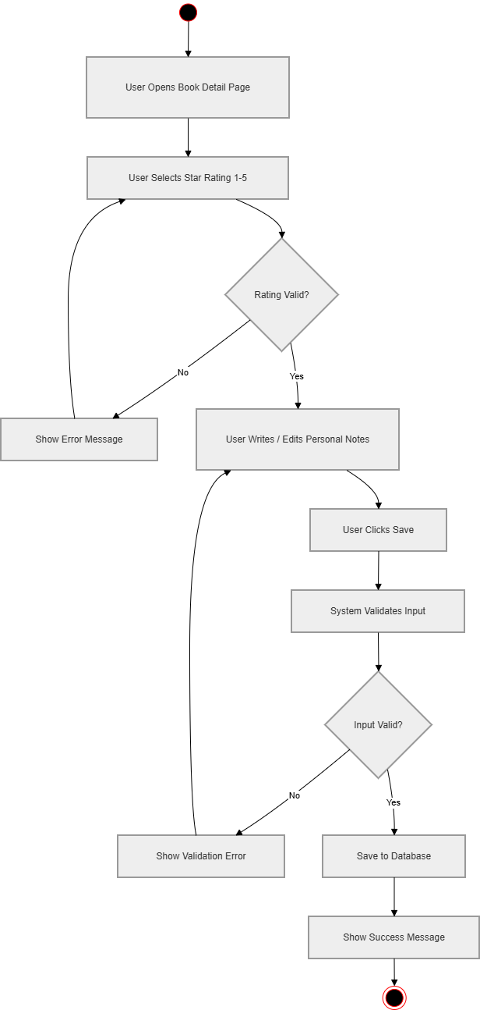
Activity Diagram 1: Ratings & Notes

Activity Diagram 2 : Reading Progress Tracking
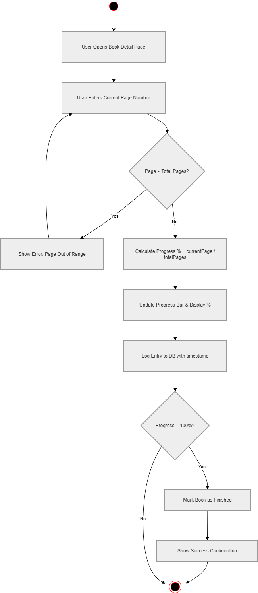

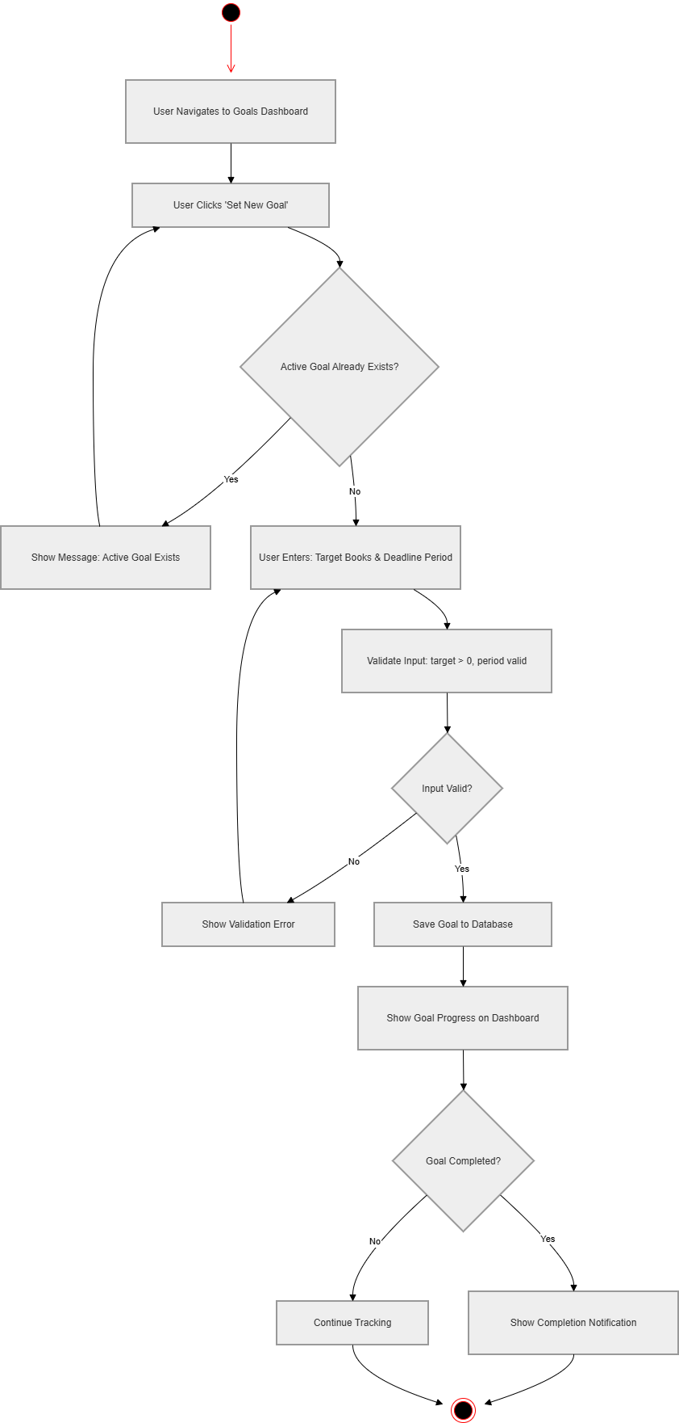
Activity Diagram 3: Reading Goals

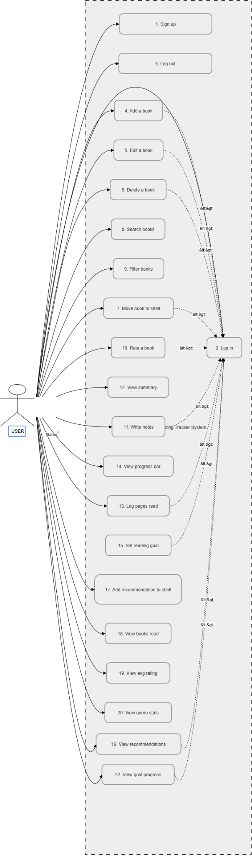
4b. Use Case Diagram

4c. Sequence Diagrams
Sequence Diagram 1 :Rate a Book & Add Notes

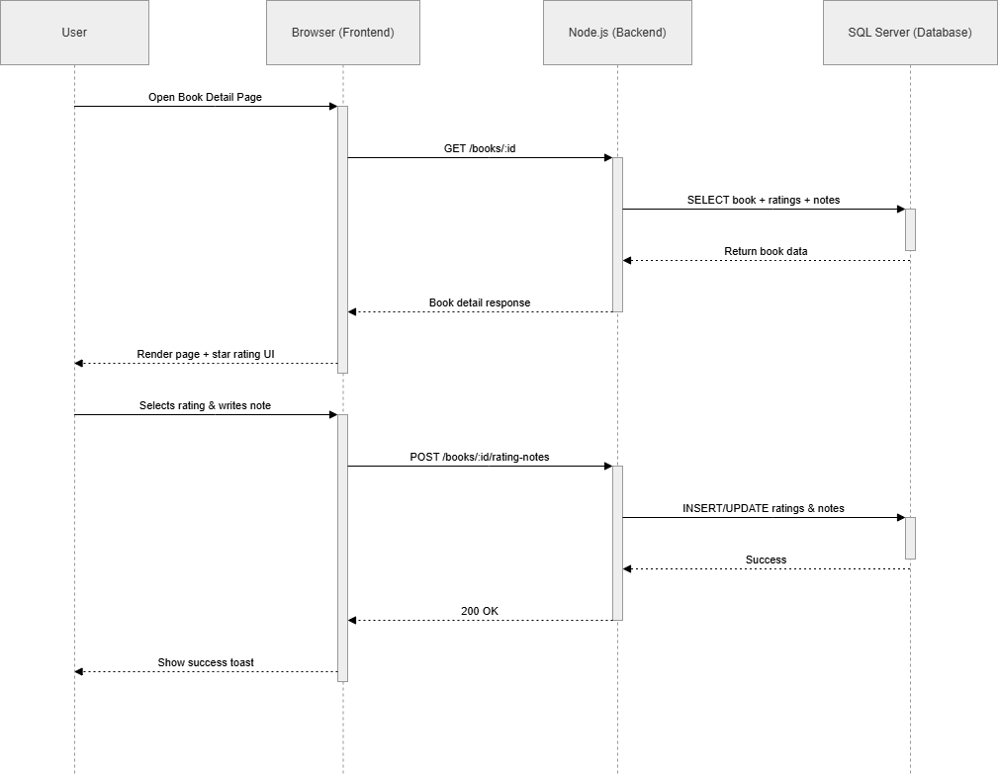

Sequence Diagram 2 : Log Reading Progress
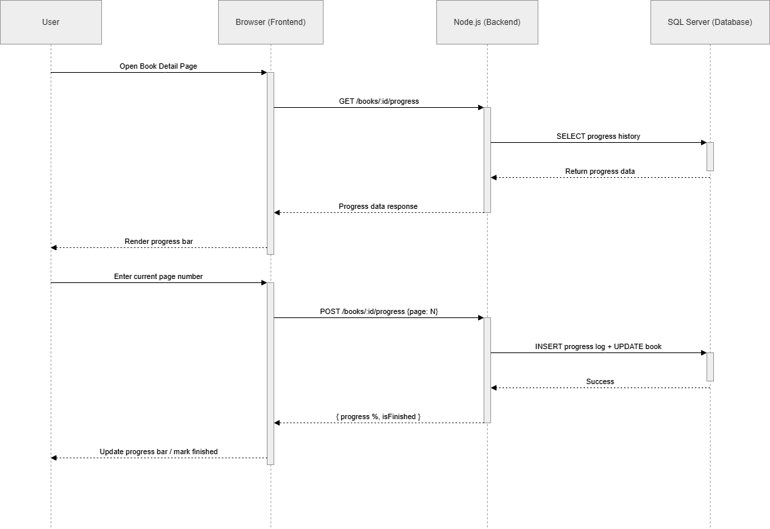

Sequence Diagram 3 : Create & Track Reading Goal
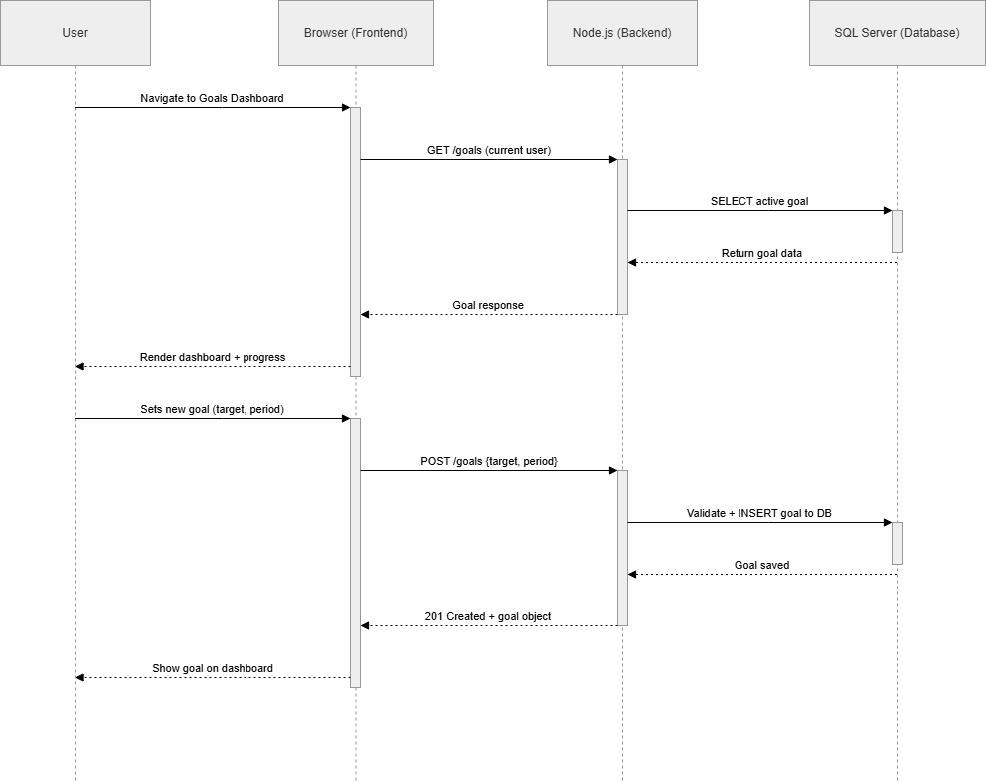

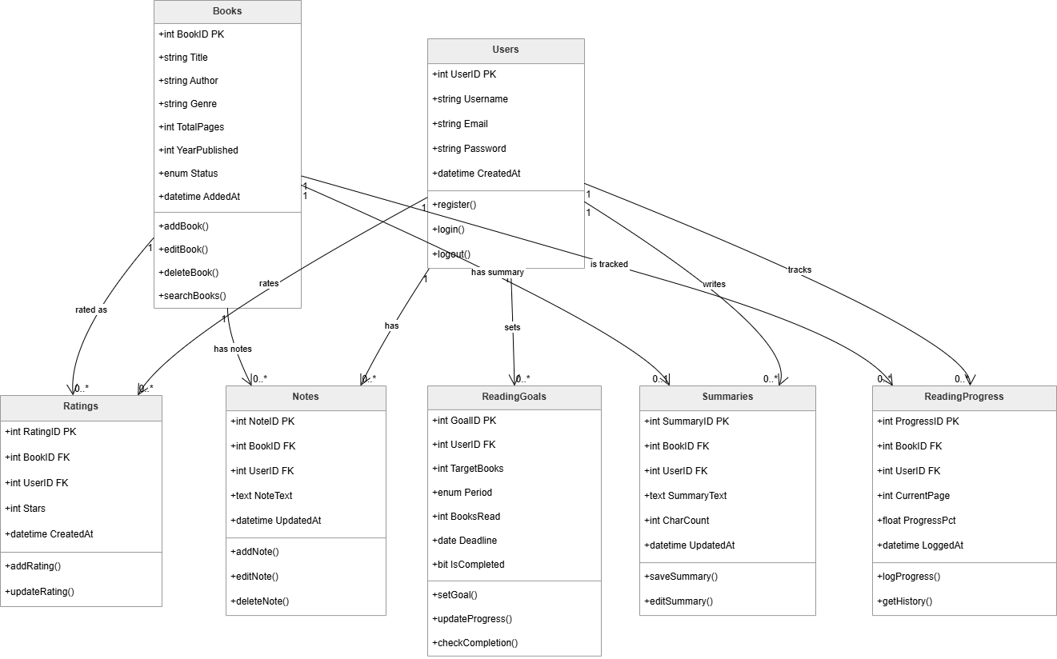
4d. Class Diagram

5. Scrum Board
The following snapshots document the state of the Trello board at three key points during Sprint 2.

Snapshot 1: Sprint Start (March 23, 2026)
All five user stories are loaded into the Sprint Backlog. No work has started yet.
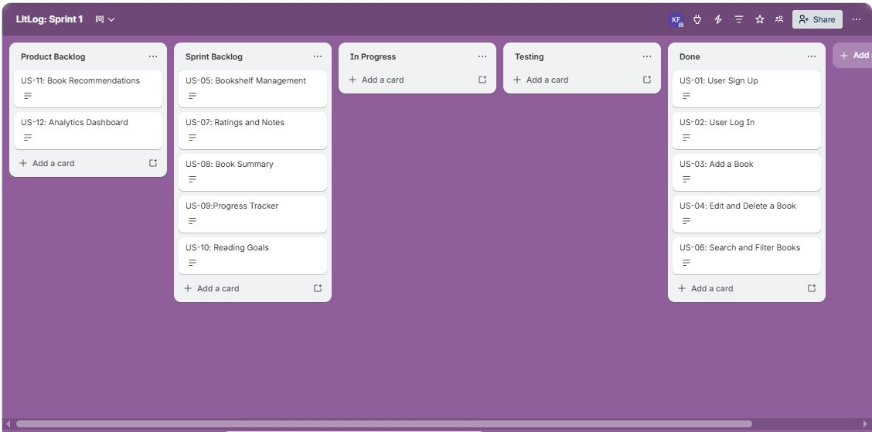

Snapshot 2: Mid Sprint (April 7, 2026)
US-07 and US-08 are completed. US-09 is in progress. US-05 and US-10 remain in the Sprint Backlog.
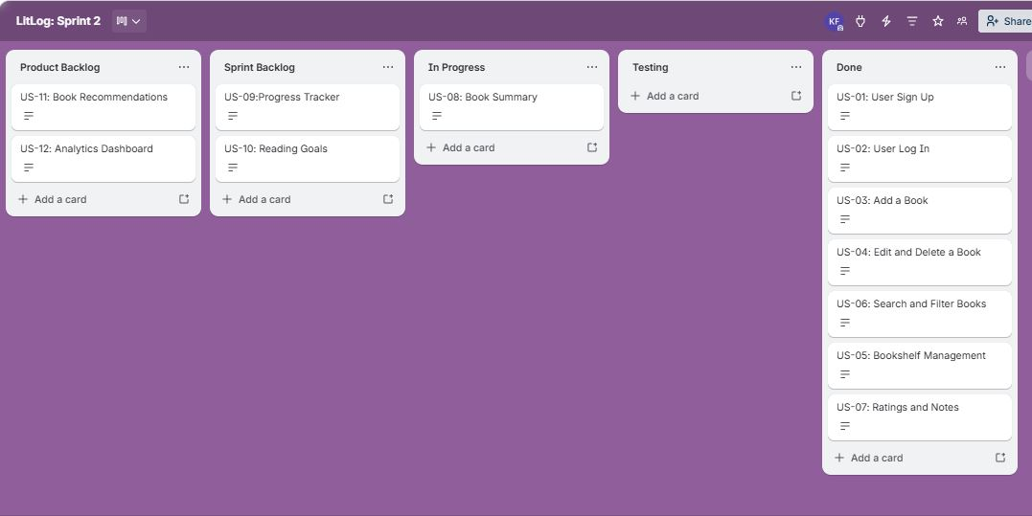

Snapshot 3: Sprint End (April 11, 2026)
All completed user stories are moved to Done. Incomplete tasks were moved back to the Product Backlog and reprioritized for the next sprint.
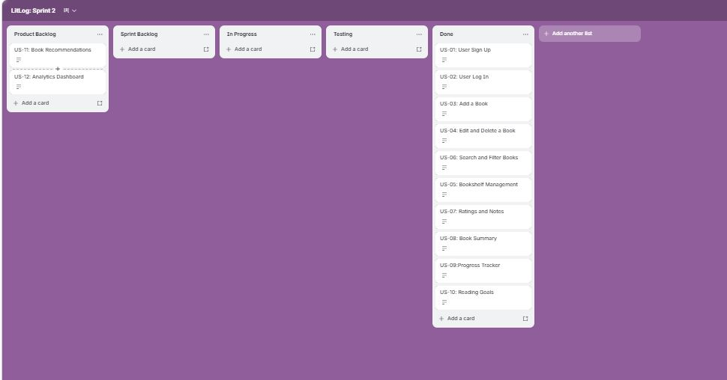

6. Non-Functional Requirements
The following non-functional requirements have been defined for LitLog using natural language specification. These carry forward from Iteration 1 and have been updated to reflect the features added in Iteration 2.
1. Performance: The system should respond quickly to all user interactions involving the book library. Loading the full bookshelf with up to 500 books must complete within 2 seconds on standard hardware. Search and filter operations should return results in under 1 second regardless of library size. The reading progress bar and dashboard analytics must update instantly upon any change without requiring a page reload. Ratings, notes, and summaries must load within 1 second of opening a book's detail screen.
2. Usability: The application should be intuitive enough for users with no technical background. A new user must be able to create an account, add their first book, rate it, and log a progress update within 10 minutes of opening the app for the first time. All buttons, shelves, and input fields must be clearly labelled with helpful placeholder text and tooltips where necessary. Error messages such as duplicate entries or empty required fields must be displayed in plain, understandable language rather than technical error codes.

3. Scalability: The system should handle growing personal libraries without any degradation in performance. It must support a minimum of 500 books per user account, at least 10 active reading goals simultaneously, and an unlimited number of notes and summaries without lag. The database schema and backend architecture should be designed to allow future features such as cloud sync, social sharing, or multi-device access to be added without requiring a full redesign of existing modules.
4. Reliability: The application should operate consistently without data loss or unexpected crashes during normal use. It must not crash more than once in 8 hours of continuous use under typical conditions. Any book entry, rating, note, summary, or progress update made by the user must be saved to the database immediately upon confirmation so that no data is lost if the application is closed unexpectedly. In the event of a failure, the user's last recorded state must be fully recoverable upon restarting the application.
5. Security: The system must protect user account information and personal reading data at all times. Each user must only be able to access their own books, notes, goals, ratings, summaries, and progress records, and no user should be able to view or modify another user's data. Any failed login attempt should display a generic error message rather than specifying whether the username or password was incorrect, to prevent information leakage.
6. Compatibility: The application must function correctly across the most commonly used desktop environments. It must fully support Windows 10 and above without any loss of features or visual inconsistencies. The interface layout must remain usable and properly formatted at screen resolutions as low as 1280x720 and as high as 1920x1080. All fonts, icons, and UI components must render consistently regardless of the operating system or display scaling settings used on the host machine.
7. Implementation Screenshots
The following screenshots demonstrate the working implementation of Sprint 2 features.
Library Interface:
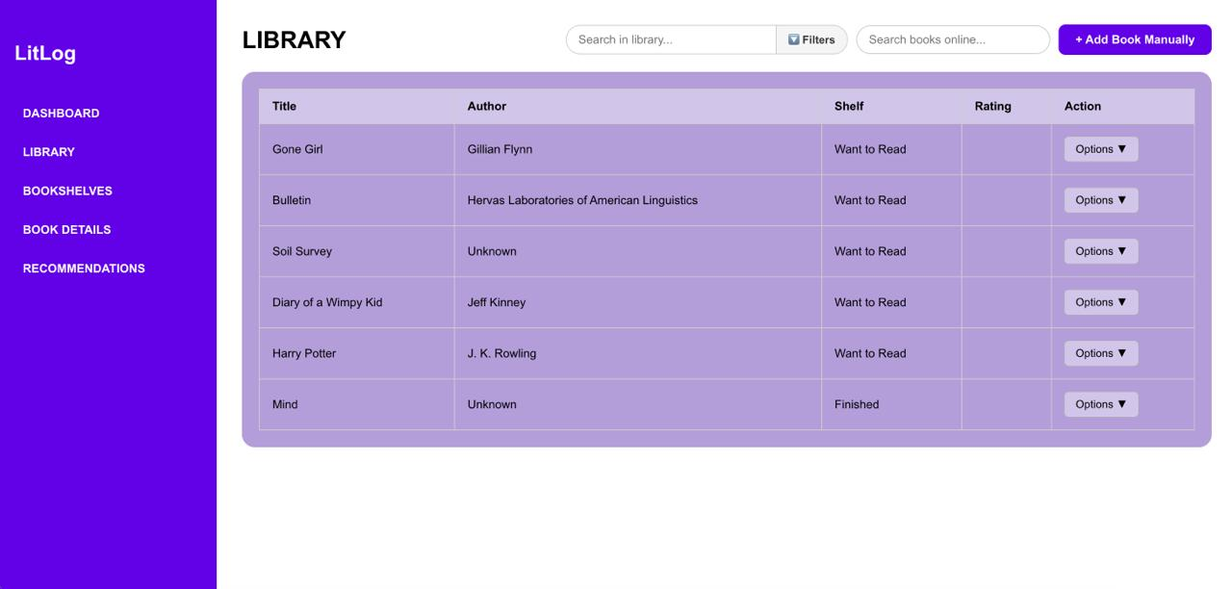

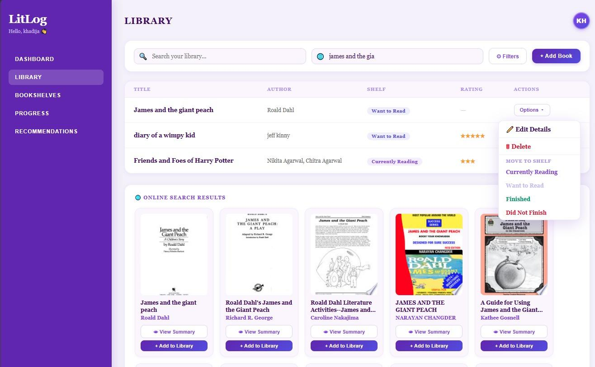
Ratings & Notes Interface:
Update Rating Backend:
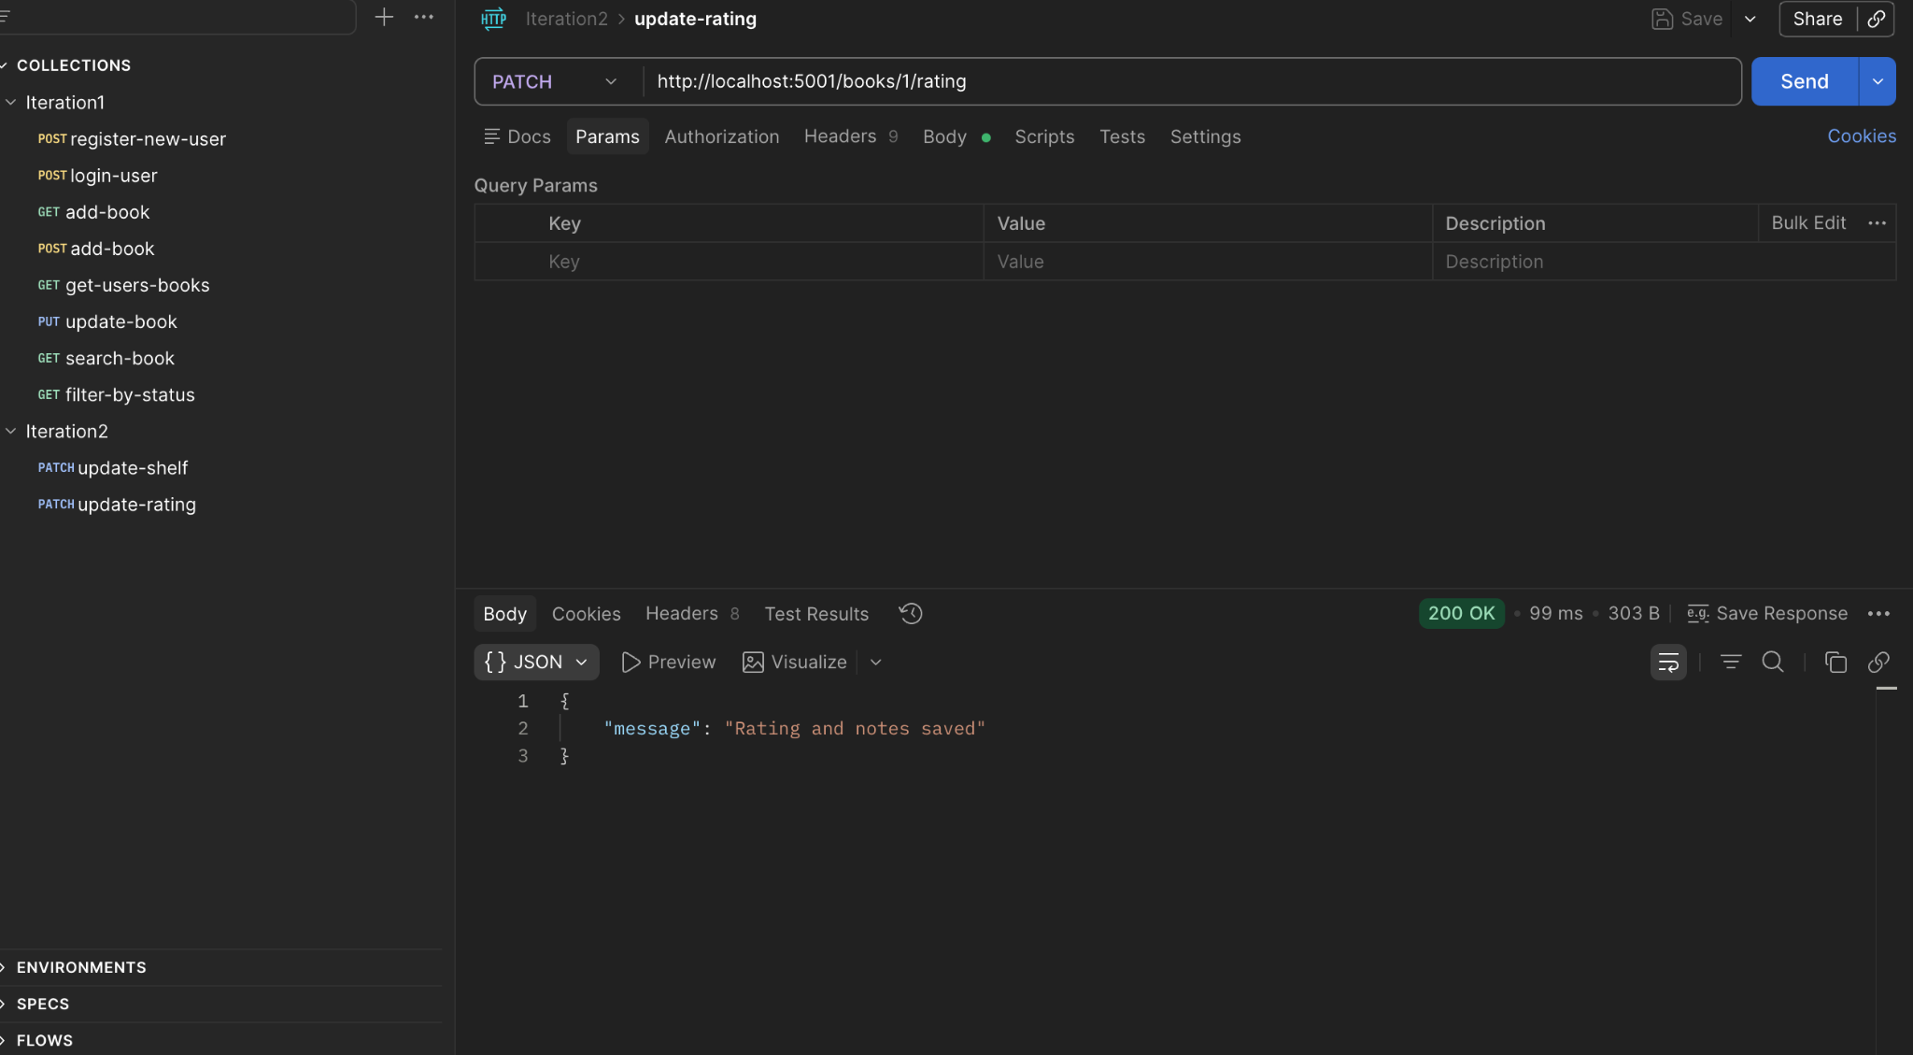

Update Shelf Backend:
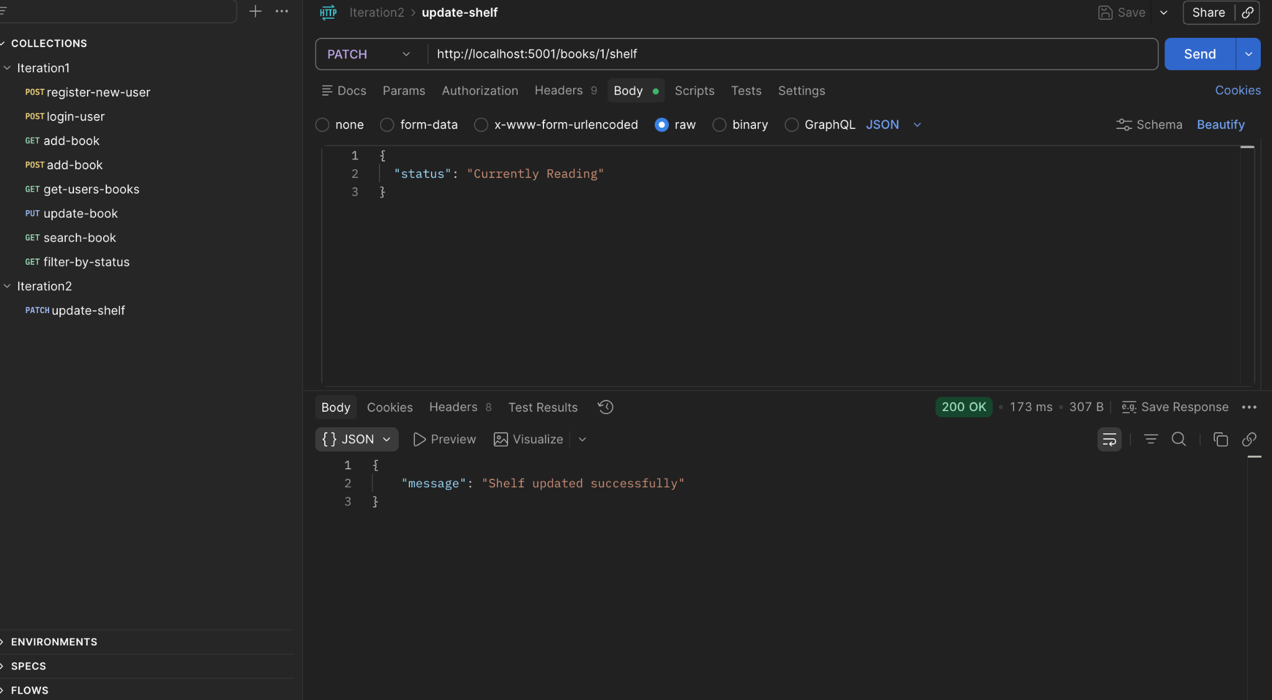

Update Target Backend:
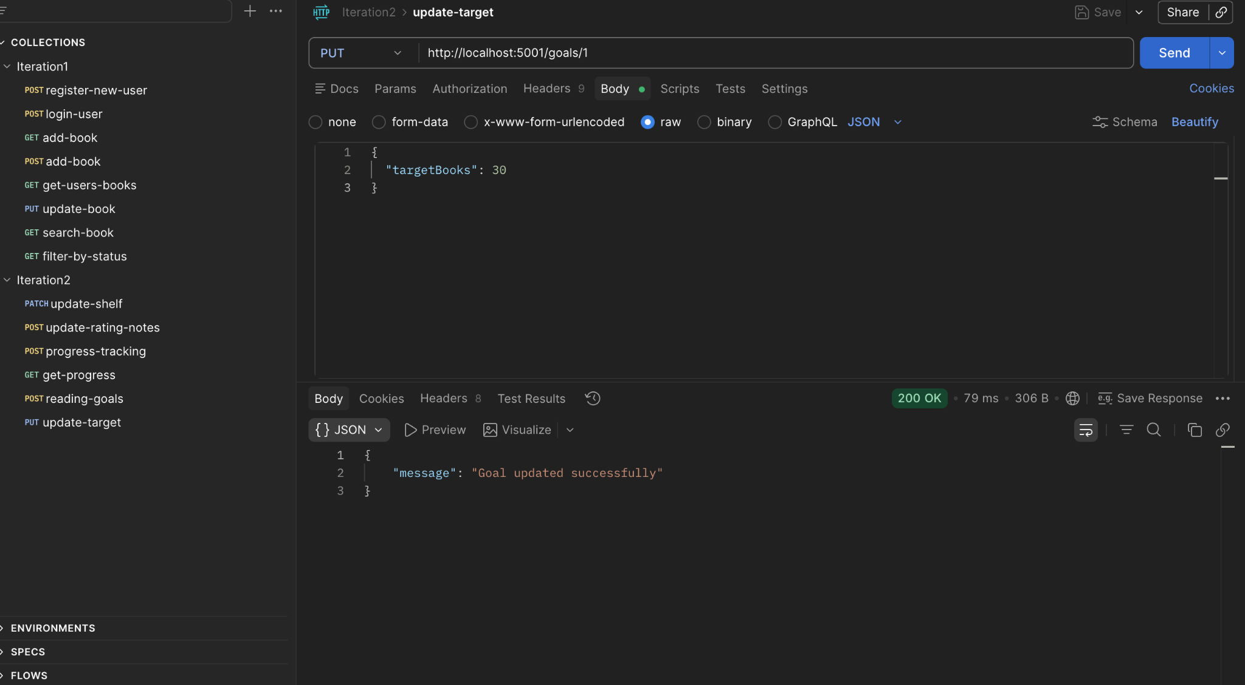

Book Summary Screen:

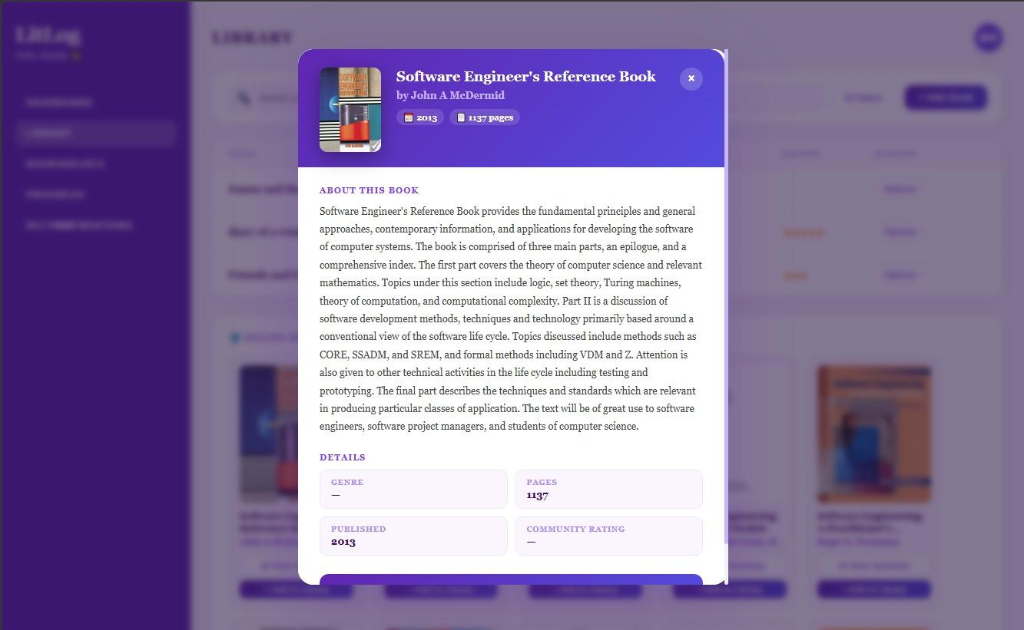

Progress Tracker:
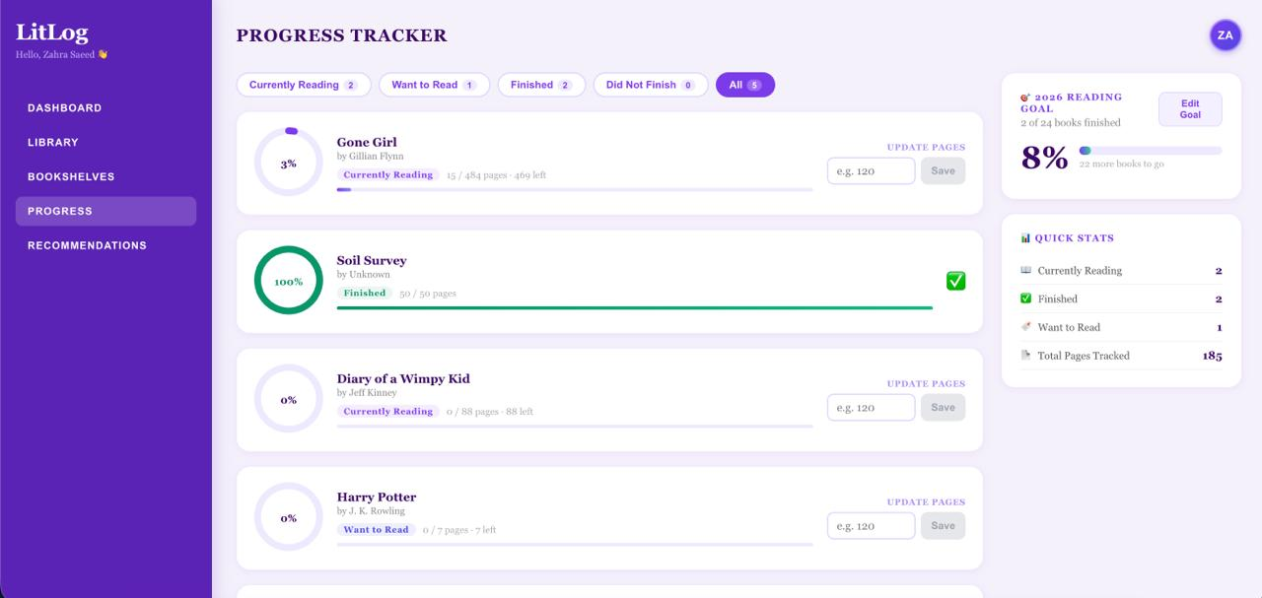

Get Progress Backend:
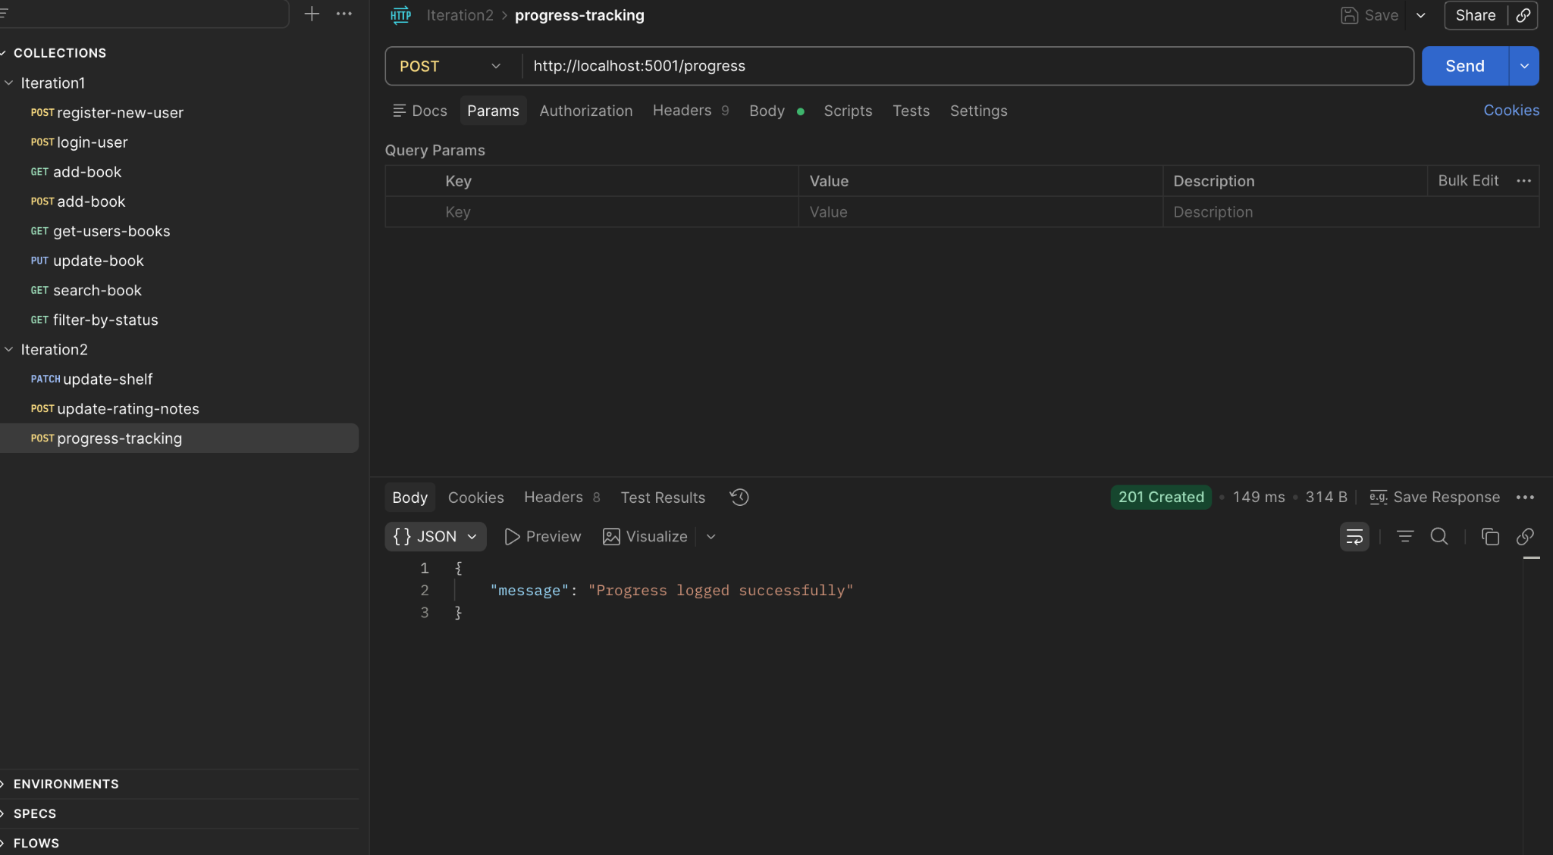
Reading Goals Dashboard:
Get Goals Backend:
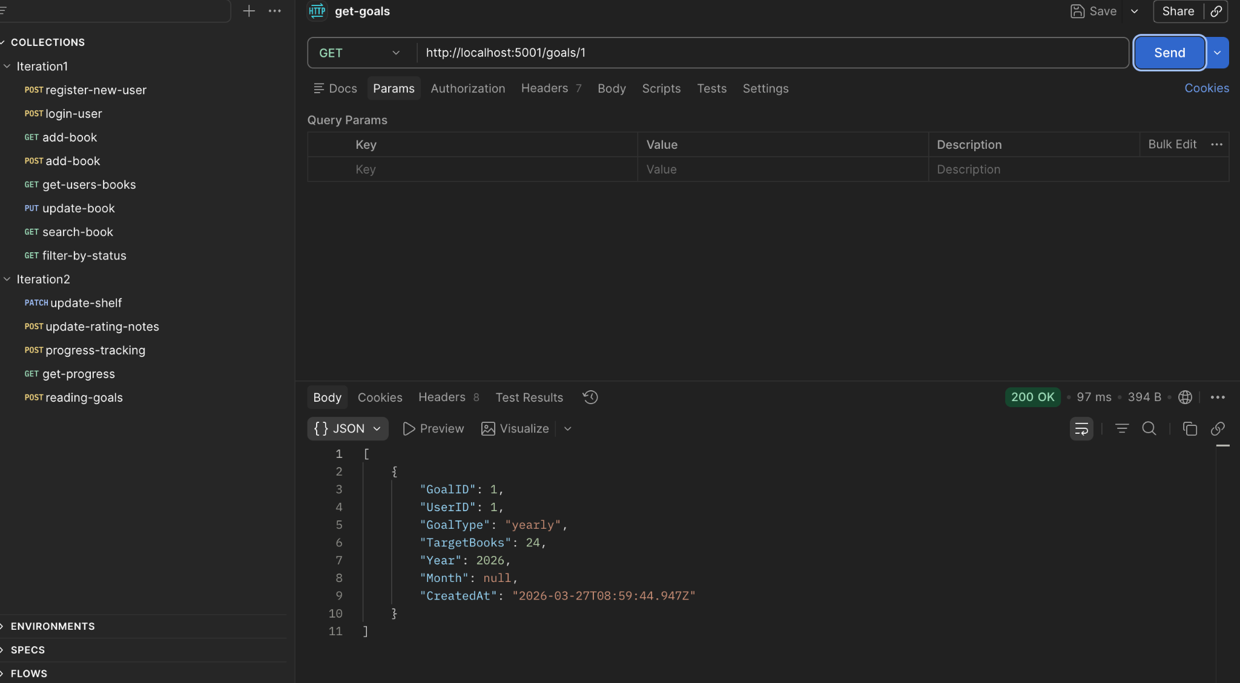

Reading Goals Backend:
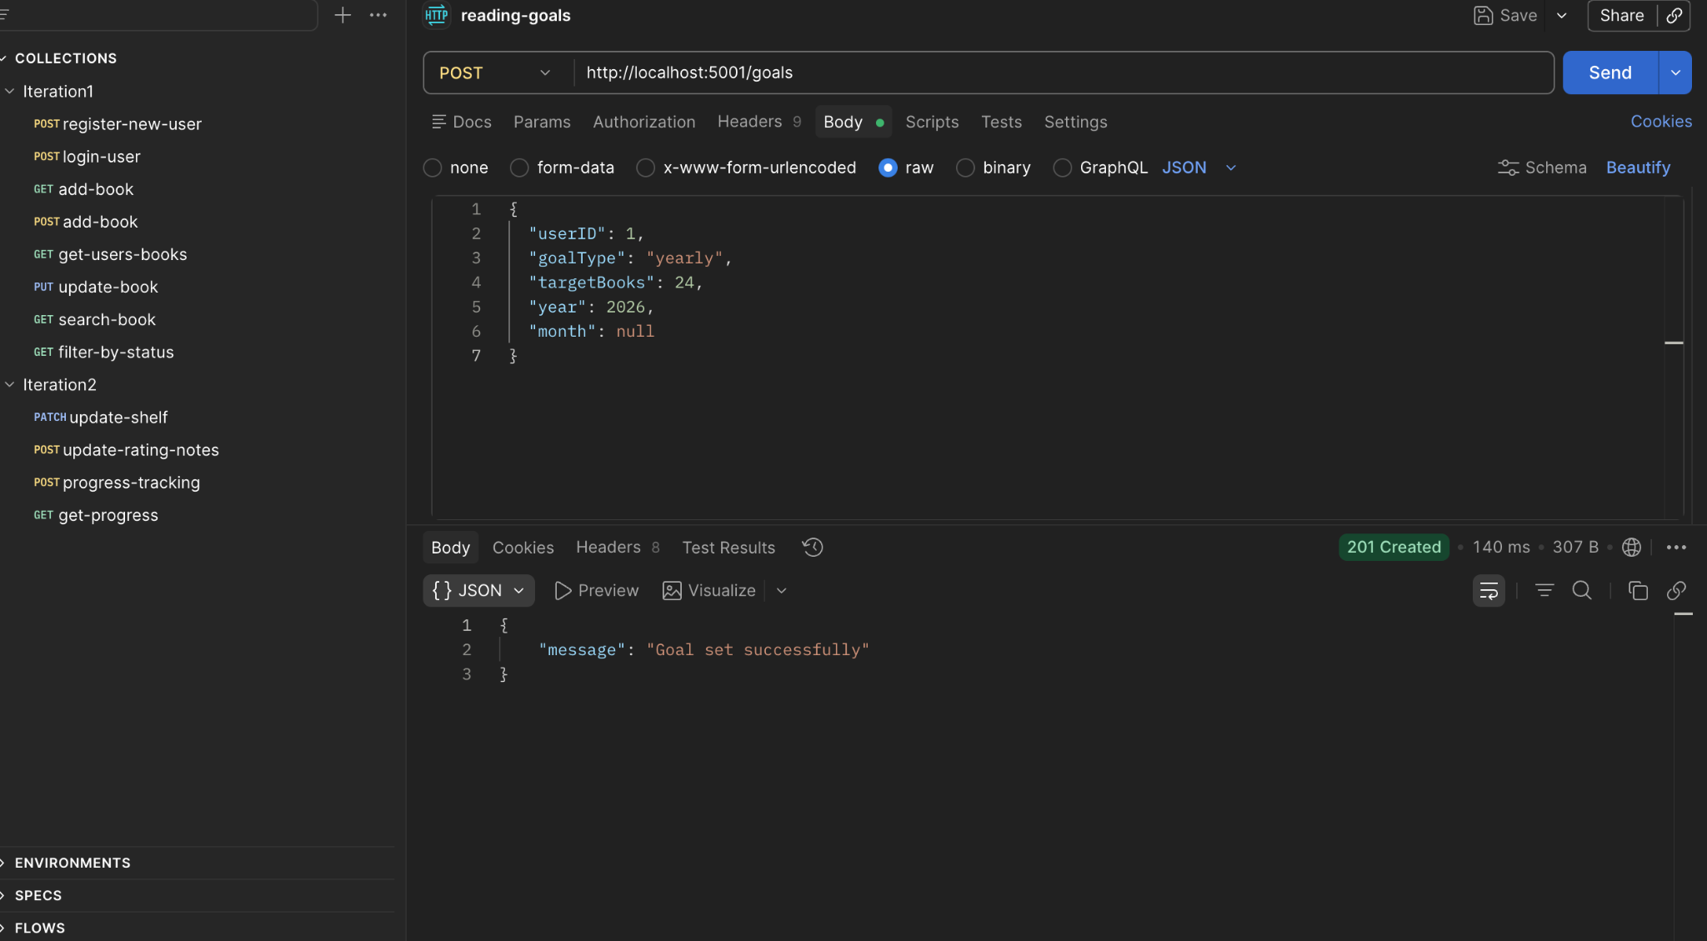
Bookshelves:
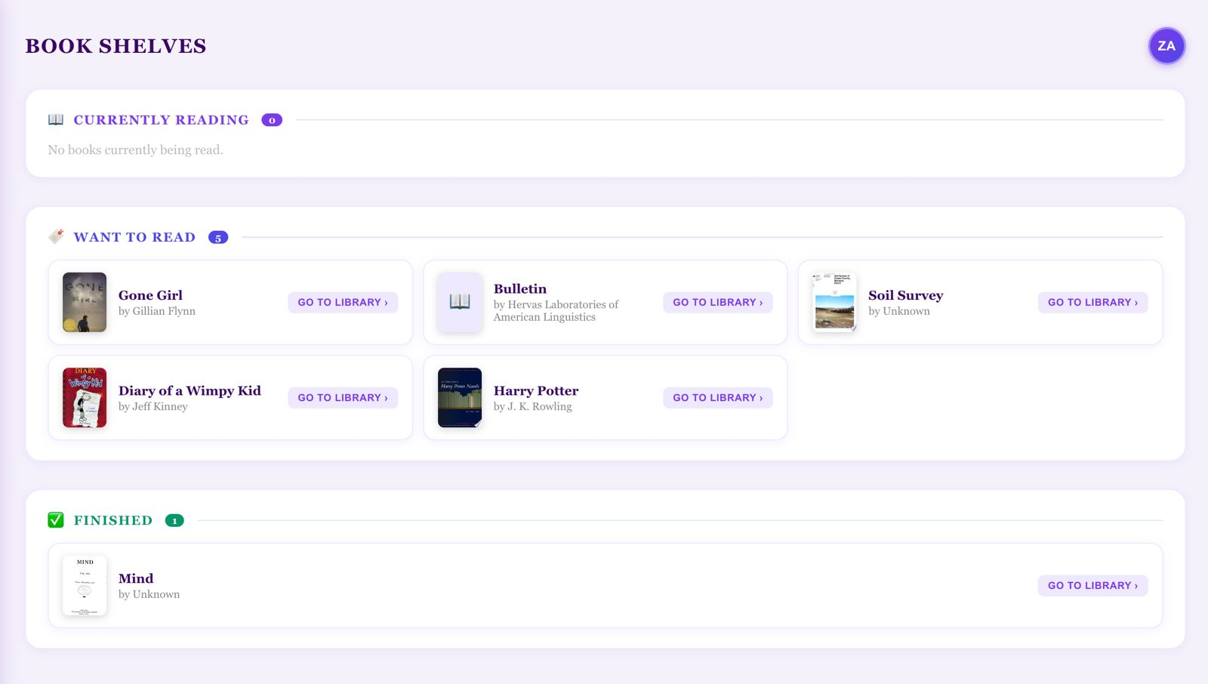

Dashboard:
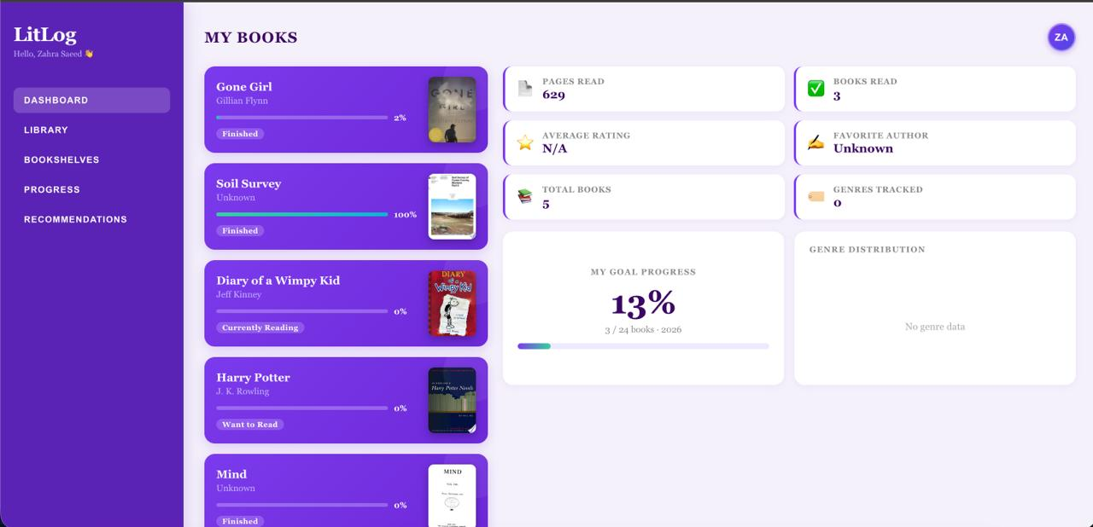

8. Work Division
The following table outlines the contribution of each team member during Sprint 2.
Team Member | Tasks Completed | Role
Khadija Faiz | Sprint backlog, user stories (US-05, US-07, US-08, US-09, US-10), structured specifications, activity diagrams, use case diagram, sequence diagrams, class diagram, NFRs, Trello board, database schema, report assembly. | Scrum Master
Zahra Saeed | Backend: Set up new database tables (Ratings, Notes, Summaries, ReadingProgress, ReadingGoals), API endpoints for rating, notes, summaries, progress tracking, and goals | Backend Developer
Romaisa Sajjad | Frontend: ratings and notes UI, book summary screen, reading progress tracker, reading goals dashboard, end-to-end testing of Sprint 2 features | Frontend Developer

All team members collaborated on sprint planning, daily check-ins, and reviewing each other's work before the final submission. The Scrum Master Khadija Faiz was responsible for ensuring the documentation matched the implemented features and that all acceptance criteria were verified before the sprint was closed.

